FORMAT FOR ANNUAL REPORT 20__ OF ICAR-AICRP ON SPICES

- Content sheet with index and page numbers
- History & background information of the centre – one page (including agroclimatic zone, soil texture, carbon content etc)
- Spices Varieties released from the centre (AICRPS/CVRC/SVRC) during 20__ (attach the original photograph with 300 dpi) as separate file along with email.
- Details of Spices-technologies (Products/ process protocol/ Machines/ gadget/ Software module) transferred to FPO/Companies reflected as tangible products during 20__ (attach the original photograph with 300 dpi) as a separate file along with email. (attaching samples for references)
Samples for references
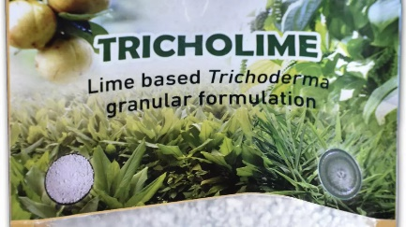 | 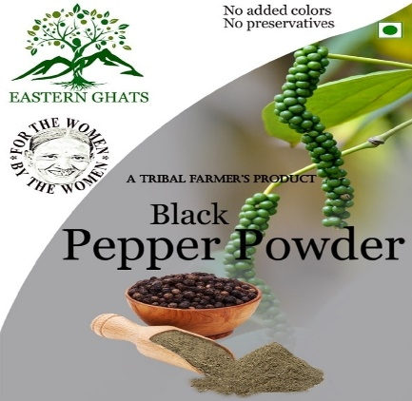 | Vertical farming POP-Turmeric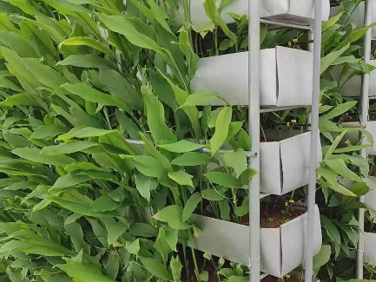
- List of projects – Crop-wise and discipline–wise.

- List of Ongoing projects of each centre
- List of New projects started
- List of closed projects as well as suggested for closure

- Summary result of each project – Crop and discipline-wise (one-page note) with tables if available

- Progress of work and achievements – of each technical programme

Each project should contain the following details (crop-wise and discipline-wise) - Officer/s associated

- Crop:
- Discipline (genetic resources/crop improvement/crop management/crop protection):
- Project code, title and year of start:
- Technical programme (Experiment) details: Design, No. of treatments/genotypes with details, Replications, Plot size/spacing, Date of sowing/planting and season (Kharif/Rabi) and Date of harvesting. (Retain the sequence of treatment as decided in workshop)
- Results & achievements with salient findings
- Table of replication wise and pooled data analyzed statistically for the year.

- Final report(s) of the closed project(s) should contain replication-wise data, pooled data, analyzed statistically and cost-benefit ratio. This report should be in the form of a research paper containing introduction, material and methods, results and/or discussion and references.

- Genetic Resources of spice crops maintained at each centre (collections with unique traits made during 20__ crop wise/No of accessions evaluated/No. of accession to be evaluated/No. of accession where IC Nos. are obtained/to be obtained/Unique Acc. if any).
Attach the relevant original photograph of unique accessions for peculiar traits if there.

- Details of production and distribution of planting materials/seeds/seeds of new varieties, quantity of seed agency to which supplied even with funding of DASD

- Revenue generated (20__- 20__) in each centre

- List of publications. Reference should be written as per the previous annual report
A. Research Paper & Review Article
Sl.No. | Authors | Title | year | Journal | Vol | issue | pages | NAAS Score (20__)
1
2
3
B. Books
Sl.No. | Authors | Name of Book | year | No of pages | Publisher | country | ISBN
1
2
3

C. Book Chapter
Sl.No. | Authors | Title of chapter | Book Name with authors | year | Pages no. | Publisher | country | ISBN
1
2
3
D. Chapter from Compendium/Proceedings of seminar /Symposium/Conference attended
Sl.No. | Authors | year | Title | Name of symposium with place and date | Pages no. | ISBN
1
2
3
E. Technical Bulletins/Manuals
Sl.No. | Authors | year | Title | Pages no. | Publisher | ISBN
1
2
3

F. Press Information (Newspaper/Internet/Blog/YouTube videos etc)
Provide information with relevant details like Newspaper cuttings/ hyperlinks to find internet sources and YouTube videos.

- Awards and Recognitions

- The monthly meteorological data

- Technology ready for transfer in detail

- Success stories
- Technologies demonstrated
- List of seminars/Melas/Exhibitions/Radio talks attended/organized
Attach photograph of distinguishable visitors if there.
- 2-3 good photographs for each of the above experiments/Technologies (Photos should be sent in jpg format with the title)
- New projects taken up in
- TSP/SCSP Activities
- NEH activities/Aspirational districts
- Budget Allocation & Head wise Expenditure - (ICAR & SAU share) Released & Expenditure

- Staff position – Sanctioned & in position of each centre (Scientific, Technical)

- Latest area & production of Spices in the state

- Annexures- Tables & results of each experiment

- Trainings and capacity-building programmes attended
Sl.no. | Date | Details of training | Sponsor/organizer | No. of beneficiaries

- Identified best productive units in the respective crop

- Areas where completely safe spice cultivation is taken up

- Farmers awarded for their success in spice cultivation

- Students guided & title of the thesis with salient achievements.
Student Name | MSc/PhD | Subject | Guide | Title | Year of Award | salient achievements

- All the centres should submit the annual report material in the above format and do not cut short or change the serial no. for the easy compilation.

- Need not include station trials/projects funded by other agencies

